

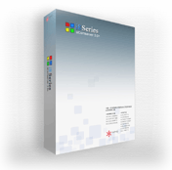

Easy to use, Easy to Install, Easy to Upgrade:

Next generation intelligent e-Business platform

“The most important thing for doing business is to balance factors like cost and investment. Bring IT into focus in business-view, many traditional rules would still applicable, one simplest is that you have to make profit in the smartest way in the quickest time with lowest cost and maximized expectation of profit in a relatively intelligent way and we focus on two things: Power to Growth & Cost Effectiveness.

— Phentony Ching

Introduction
The need to contain costs and boost return-on-investment (ROI) is forcing companies, not only Internet-hooked business, but also traditional firms, across different industries and geographies to streamline their business model and processes. Businessmen and managers are now being asked more frequently then ever they do in the past to do more with less, and to build better e-business application, if not just working environment that they think that also decides the whole business model, for profit, not just for survive.

Under fiscal pressure, IT managers are forced to launch revise their strategies, adopting advanced Web Technologies and methodologies, all in the name of creating cost- and process-efficient e-workspaces. While IT support is of course crucial to this endeavor thorough workspace transformation request amending business process and managing change throughout the corporate culture.

Fundamental to the concept of e-Business / e-Commerce is the Working Application Platform – an automatic interface to the market. Consistent, efficient, automatic, reliable, extensible, together with effective customer services --- are in large part responsible for sustaining brand loyalty and overall e-business success. While technologies now afford more opportunities for marketing to, selling to and serving customers, a flexible, responsive and progressive online-business initiative – capable of boosting rate of online successes, is a critical component of any true e-business platform: an Intelligent Business Platform.

Intelligent business platform brings traditional way of doing business to the Internet in the most efficient and seamless and proactive way. In this aligned environment, everyone is well conducting their desired responsibilities and wise communicating with each other, such as buyers, sellers and traders.

Perhaps most importantly, e-business platform initiatives should be implemented strategically, on a programmatic basis. Costly and redundant processes, such as multiple human resource activities --can be addressed promptly to help achieve rapid and reliable return on investment (ROI). In this way, leading-edge technologies and e-business applications can be chosen carefully and leveraged appropriately to provide direct and continuing value to online-businesses of all sorts and sizes.

Toward this end, HKTI has developed a suite of proven, workforce-centric solutions designed to help organizations realize immediate cost savings, operational efficiencies and progressive structural change. HKTI’s Business Intelligent Platform based solutions offers both standards-based and modular - and may be applied alone or in combination, helping to assure rapid deployment, reduced risk and customized value. The HKTI solution set includes technologies and services enabling, as well as e-Shop, e-Mall, e-Trade, e-Marketplace, e-Portal and e-Customer self-service.

Trends and Directions

In today’s e-Commerce environment, demands for effective internet marketing, efficient management, usability, flexibility, language support, extensibility, availability and intra- and extra-enterprise relationships continue to rise.

To meet these expectations, organizations must establish a wholly integrated infrastructure that is capable of providing compelling and timely content and connections to the right people in the right way whenever they need it. At the same time, visionary businesses must build flexibility into the corporate culture, helping to ensure their ability to respond to, learn from and fully exploit today’s diverse and dynamic e-marketplace.

It’s no wonder that more and more businessmen are realizing the real value of Web-enabling their businesses. At the same time, successful e-businesses are those that go beyond mere implementation of Web-Technologies to do online businesses capable of driving more incoming profits.

E-Business initiatives may include business-to-business trading/transaction platforms, business-to-customer shopping mall or portals, customer-to-customer exchange portals, business-to-employee (B2E) enterprise portals, online-business-centric solutions. Small and large business alike can learn to leverage e-business principles and processes internally to optimize their business and revenue model. Once an overarching strategy is in place, solutions can be targeted to industry-and company-specific concerns, deployed in phases to enable a direct value-add to the business. These actions, can go a long way toward helping companies put their own houses in order.

Benefits of e-Business initiative

An e-business platform provides business value via online trading/transaction system, intelligent customer self-service, collaborative capabilities, mobile and multi-channel support and other transactional and communication functions. Together, these capabilities can transform the way people buy things.

For example, an effective e-business solution grants users secure and consistent access to people and information, via Web Browsers, mobile phones, personal digital assistants (PDA), specialized handheld devices, etc. An customer-to-customer bidding system can provide buyers and sellers at every level with information geared toward particular buying or selling patterns and needs, reducing time-consuming navigation and product searching and management redundancies for everyone.

All in all, establishing an integrated, intelligent business platform can improve information flow, derive more sales, increase public branding and loyalty, enable more cost-effective money-making process, and all relationships: among partners, sellers, buyers, suppliers, customers are managed.

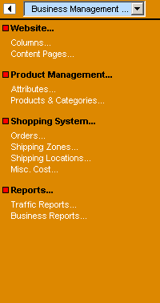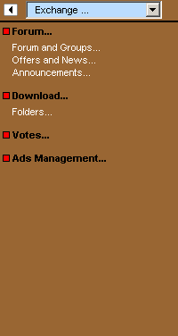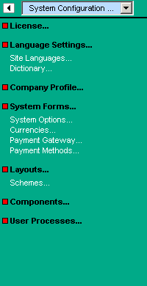

Business Management
- Content Management
- Category Management
- Cost Management
- Logs & Reports
User Management
- Administrator
- User/Members
- Privileges Management
Exchange Management
- Forum
- File Center
- Vote Management
- Ads Management
System Configuration
- Language
- System forms and options
- Layout & Scheme
- Components & processes

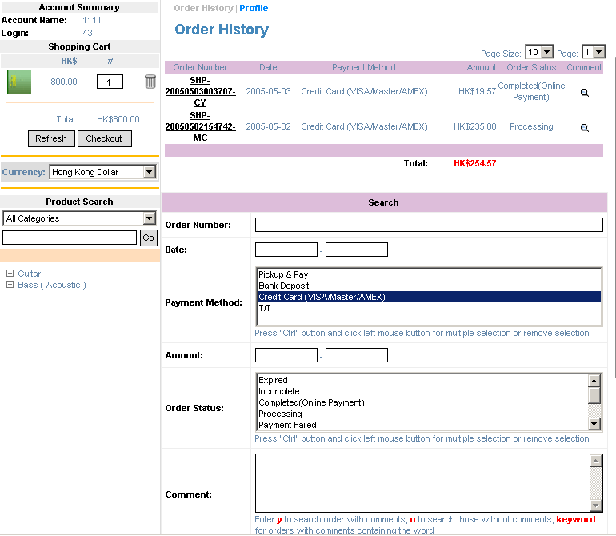

Order History

Management Panels/Options and Member Profiles
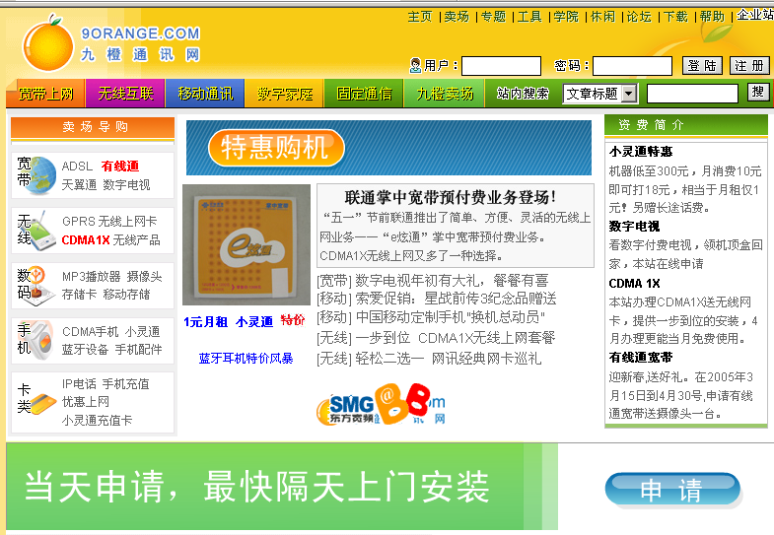

News Column
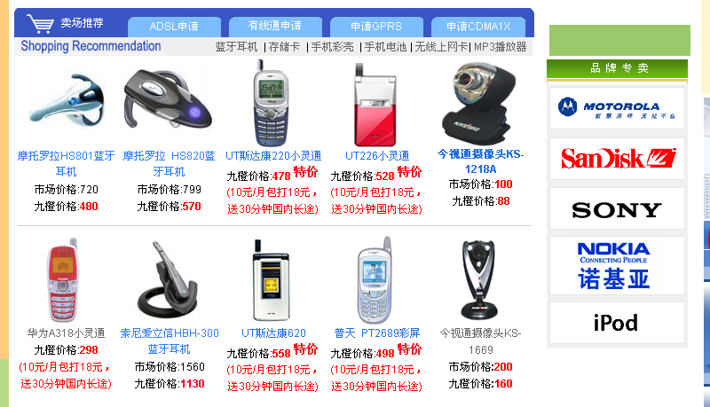

New Products

Successfully Deployed Portal

Specific business benefits can accrue in terms of:
- Cost-Containment: Mature product and component-oriented architecture can cut development expenses by going directly to business logic implementation from the first day
- Revenue-enhancement: Superior usability and built-in internet-marketing functions contributing superior customer experience
- New Efficiencies: By leveraging extensible built-in components, processes and entity concept, one can do system upgrade in no-time.

Implementing an i8IBS Solution

The critical components of an i8IBS platform can vary according to the needs of the organization. Key factors influencing the make-up of an IBS solution include industry, business model, cost and ROI considerations, the competitive environment, current systems and Web- enablement status

Many companies may choose a phased and/or modular deployment - establishing a flexible, scalable and unified framework for the overall solution upon which are built the critical applications for delivering the swiftest and most substantial benefits. A holistic, enterprise-wide approach helps to ensure that top opportunities are addressed first, and that individual initiatives do not replicate or conflict with others in the company.

Key features of an I8IBS can include but are not limited to:

The B2C portal

An e-business platform grows around a single, secure and personalized Web portal for customers seeking access to information and product. Many top online businesses maintain several highly-priced e-business platforms. The portal empowers the integration and expansion of existing system to suit for growing needs, and drive a better return on overall investment. It also establishes a fully aligned, informed and efficient foundation from which to launch other B2B, C2C initiatives.

Elements of the i8IBS Platform Offering

Language
Option
Layout
Payment
Processes
Components
Content Management
Data Management
Exchange Management
Currency
Form
Cost Mgt.
Shipping
Services & Rules
Business Logics
Membership
CMS
e-Site
e-Trade
e-BBS
e-Shop
e-Portal

Strategy, implementation, management and control

CMS
Online knowledge management and sharing platform which improves users/employees access to information and facilitates electronic processing of knowledge transfer and reservation as well as information broadcasting

e-Site
A tiny version of CMS, online content management system with little support on membership, multi-lingual support, and user exchange services, facilitates online presentation of corporate and simple online business enquiry

e-Shop
Online shopping system embedded with currency management, language management, product and catalog management, shipping cost management, membership management and other necessary modules and services facilitating firms to do online business with online transaction support and business reporting and logging

e-Trade
Online trading system powered with Stock Keeping Unit (SKU) concept, with currency management, discount management , language management, product and catalog management, shipping cost management, membership management and other necessary modules and services facilitating firms to do online trading with suppliers and customers

e-Portal
Online complex system integrating content management functions and shopping functions as well as BBS exchange functions, supporting either intranet applications or public information portals

e-BBS
Online exchange integrating membership and complex access right control management system, applicable to and facilities both online communities or project liaising application

Content Management
Featured with paragraphs as the smallest content element, enabled with privacy and access control, also with the front-end rich-content WYSIWYG editor, provides the best content management experience.

Data management
Supported with Category based data attribute management, SKU support, discount matrix, descriptive, binary and multimedia data/product attributes.

Exchange Management
Includes management of forum, document/file center, votes, ads, etc, forms one of the most fundamental and powerful elements to all above applications

Membership
Adjustable membership system, support unlimited membership types, control and extended by form and options, gives the maximum flexibility on membership extensibility to suite for needs of any kind of applications

Services & Rules
Integrated groups of business logics built on top of component pool and process pools, one can add any components and processes to provide required business processes at any time.

Option
Variations of special groups of system-wide information such as membership types, gift-wrapping selection, order-types, country list, etc.

Form
System or User-defined business forms for information passing between different application and services. Highly flexible and integrated with Options facilitates extensibility.

Shipping
4-Level shipping zone and location definition, with incremental shipping weight and cost concept, also supports free margin as respected to the amount of order sums

Cost Management
Miscellaneous cost management, providing flexibility extra to shipping cost, such as handling fee, optional fee and default charges

Business Logics
Defines how user would have experienced while using the system, such as interface blocks and carrying out business operations. This is highly extensible, supports Web Services and Cross platform operation

Language
Supports up to maximum 5 types of languages being used in an application at the same time, featured with dictionary management.

Layout
Component based layout, highly adjustable and can be management online, controls front-end interface of whole system, also featured with multiple instances of pages and layout relationship.

Currency
Unlimited number of currencies can be added and supported, as well as currency rate and Integratable to payment gateway

Payment
Flexible and customizable payment method management and online payment gateway management give businessmen the optimized path to do online businesses

Components
Embedded in layouts, defines and control how system front-end appears. Components can be shifted from one layout to another layout, and supports multiple-instances to give the maximum support of business logic location flexibility

Processes
Controls how member actions and business management operations are being responded, as well as auto-logging and reporting function.

System | Target |  | System | Target
e-Shop | Reseller, Brand Franchise |  | cms | Departments, educational organizations, content providers
e-Trade | Manufacturer, Wholesaler |  | exchange | Project development team, SOHO
e-Catalog | Manufacturer, reseller and wholesaler |  | CMM | Sales Department, Human Resource
e-Portal | Industry Focused content provider, consulting firms |  | e-Site | Companies, organizations or individuals
e-Marketplace | Distributor, Direct sale |  | e-BBS | Companies, organizations or individuals

I8 Business Intelligence: Better business

I8 BI Lab, though small, but arguably one the most mature and most successful laboratories/companies on researching e-business capabilities, has already web-enabled its own optimized workspace.

Our modular design, standard API allows our users to add more business functions very easily, can be integrated with our i8 passport to share member resources (millions of members) with other i8 system users. Organized information broadcasting give you a better channel for you to marketing your organization and information without any risk.

Suggested Management Flows

e-Shop

Configuration

Reseller：Setup the platform
User: Get user manual
Self-Init?
Y
Running
N
System Language
(14)
Organization Information
(15)
Currency
(18)
Payment Gateway
(19)
System Forms
(17)
System Option
(16)
Layout
(20)
Product & Services
(2)

Shipping & Cost
(5)

Comments
(13)

Membership
(8)
Administrator
(7)

Loop
Orders
(4)

Reporting
(6)

Content Publishing
(1)

e-Trade

Configuration

Reseller：Setup the platform
User: Get user manual
Self-Init?
Y
Running
N
System Language
(14)
Content Management
(1)
Currency
(18)
System Form
(17)
System Option
(16)
Layout Management
(20)
Products & Categories
(2)

Members
(8)

Comments
(13)

Enquiries
(4)
Administrators
(7)

Loop
Reporting
(6)

e-Catalog

Configuration

Reseller：Setup the platform
User: Get user manual
Self-Init?
Y
Running
N
System Language
(14)
Content Management
(1)
Currency
(18)
System Form
(17)
System Option
(16)
Layout
(20)
Products & Categories
(2)

Comments
(13)

Administrators
(7)

Loop
Reporting
(6)

e-Portal

Configuration

Reseller：Setup the platform
User: Get user manual
Self-Init?
Y
Running
N
System Language
(14)
Columns
(1)
Payment Gateway
(19)
Ads
(12)

Content Publishing
(1)
Layout Design
(20)
Orders
(3)

Comments
(13)

Administrators
(7)

LOOP
Reports
(6)

Component Management
(A1)
System Processes
(A2)
Votes
(11)
Forums
(9)
Currency
(18)
Shopping Mall & Fees
(2,5)
System Forms
(17)
System Option
(16)
Members
(8)

Files
(10)
CMS

Configuration

Reseller：Setup the platform
User: Get user manual
Self-Init?
Y
Running
N
System Language
(14)
Columns
(1)
Contents
(1)
Layout Design
(20)
Administrators
(7)

LOOP
Reports
(6)

Components
(A1)
Processes
(A2)
Forum
(9)
System Forms
(17)
System Options
(16)
Members
(8)

Files
(10)
Knowledge
(wiki)
e-Site

Configuration

Reseller：Setup the platform
User: Get user manual
Self Init?
Y
Running
N
System Language
(14)
Content Publishing
(1)
Layout
(20)
Administrators
(7)

Loop
Reports
(6)

Organization Profile
(15)
System Forms
(17)
System Option
(16)
e-CMM

Configuration

Reseller：Setup the platform
User: Get user manual
Self-Init?
Y
Running
N
System Language
(14)
Content Publishing
(1)
Components & Processes
(A1, A2)
Administrators
(7)

LOOP
Members
(8)

Company Profile
(15)
System Forms
(17)
System Option
(16)
Reports
(6)

Project Exchange/ Forum
(9)
e-BBS

Configuration

Reseller：Setup the platform
User: Get user manual
Self-Init?
Y
Running
N
System Languages
(14)
Layouts
(20)
Administrators
(7)

LOOP
Members
(8)

Organization Profile
(15)
System Forms
(17)
System Options
(16)
Forum
(9)

Content Publishing
(1)
Reports
(6)

e-Exchange

Configuration

Reseller：Setup the platform
User: Get user manual
Self-Init?
Y
Running
N
System Language
(16)
Layout & Design
(20)
Administrators
(7)

LOOP
Members & customers
(8)

Organization Profile
(15)
System Forms
(17)
System Options
(16)
Knowledge and Projects
(9)

Content publishing
(1)
Reports
(6)

i8IBS: Solution for e-Business

The IBS platforms are module and role-based, which are developed to provide direct and specific values to online business and professionals in virtually every sector of doing online businesses. HKTI consultants are prepared t work with your enterprise to assess and define and which services could most benefit your business and provide the most rapid financial returns.

The HKTI solution set is one of proven and virtually unparalleled breadth and depth. Our services include, but not limited to:
- E-Business Application Development
- E-Business Solution Providing
- Payment Gateway Integration
- Mobile-Commerce Solution
- Online Content management

We support these services by applying a broad range of capabilities, including:
- Workplace and portal strategy
- E-Business strategy and consultation
- Enterprise content management
- Security services
- Data & IT Hosting
- Industry-specific expertise

HKTI’s I8BI Series of products is fueled by flexible and extensible server technologies and fortified search, multi-lingual, personalization capabilities and collaboration and online-business functionalities.

Our consultants can design a customized e-business framework for your online-business, helping to ensure seamless deployment on an aggressive timeline. Plus, we can assist in planning for and managing the systemic changes to fulfill your strategy.

With HKTI, you can realize the value of a comprehensive e-business solution, proven and prepared to grow.

For more Information
To find out more about how I8IBS might best serve your business, contact us by visiting:

hktechnology.com/

